LIBRARY MANAGEMENT SYSTEM

1. Project Overview
The Library Management System is a web-based application developed to manage book records in a simple and organized way. The system allows users to add, view, update, delete, and search book details.
The application uses a frontend interface connected to a Django backend through REST APIs. The book information is stored in an SQLite database.
The main purpose of this project is to demonstrate a complete CRUD-based web application with frontend, backend, database, API integration, validation, and testing.

2. Problem Statement
Managing library book records manually can be time-consuming and may lead to errors or difficulty in finding information.
A digital Library Management System can make book management easier by providing a single application to store and manage book details.
This project provides a simple interface where book records can be created, viewed, modified, deleted, and searched.

3. Objectives
The main objectives of the project are:
- To develop a simple web-based Library Management System.
- To implement CRUD operations for book records.
- To store book information in a database.
- To create REST APIs using Django REST Framework.
- To provide an easy-to-use frontend interface.
- To implement basic input validation.
- To test the working of the application.
- To maintain the project using Git and GitHub.

4. Technologies Used
Technology | Purpose
HTML | Structure of the webpage
CSS | Styling and responsive design
JavaScript | Frontend interaction and API communication
Python | Backend programming
Django | Web framework
Django REST Framework | REST API development
SQLite | Database
Git | Version control
GitHub | Source code hosting
VS Code | Development environment

5. System Architecture
The system follows a simple frontend-backend-database architecture.

Architecture Flow
User → Frontend → REST API → Django Backend → SQLite Database

Working
- The user interacts with the Library Management System through the web interface.
- JavaScript sends requests to the Django REST API.
- Django processes the request.
- Django REST Framework handles serialization and API operations.
- The database stores or retrieves the book information.
- The response is sent back to the frontend and displayed to the user.
- ┌──────────────┐
- │ USER │
- └──────┬───────┘
- ↓
- ┌──────────────────────┐
- │ Frontend │
- │ HTML + CSS + JS │
- └──────┬───────────────┘
- ↓
- ┌──────────────────────┐
- │ Django REST API │
- │ /api/books/ │
- └──────┬───────────────┘
- ↓
- ┌──────────────────────┐
- │ Django Backend │
- │ Models + ViewSet │
- └──────┬───────────────┘
- ↓
- ┌──────────────────────┐
- │ SQLite Database │
- │ Book Table │
- └──────────────────────┘

6. Database Design
The project uses an SQLite database to store book information.

Book Table
Field | Data Type | Description
id | Integer | Unique ID of the book
title | String | Name of the book
author | String | Name of the author
isbn | String | Unique ISBN number
available | Boolean | Shows whether the book is available
The isbn field is unique, which helps prevent duplicate ISBN records.

7. CRUD Operations
CRUD stands for:
- Create – Add a new book.
- Read – View existing books.
- Update – Modify book information.
- Delete – Remove a book.

CRUD Implementation
Operation | Description
Create | Adds a new book to the database
Read | Displays book records
Update | Changes existing book details
Delete | Removes a book from the database
The CRUD operations are implemented using Django REST Framework's ModelViewSet.

8. API Documentation
The application provides REST API endpoints for managing books.

Base URL
/api/books/

API Endpoints
Method | Endpoint | Purpose
GET | /api/books/ | Get all books
POST | /api/books/ | Add a new book
GET | /api/books/{id}/ | Get a particular book
PUT | /api/books/{id}/ | Update a book
PATCH | /api/books/{id}/ | Partially update a book
DELETE | /api/books/{id}/ | Delete a book

Example Book Data
{
"title": "The Alchemist",
"author": "Paulo Coelho",
"isbn": "9780061122415",
"available": true
}
The REST API allows the frontend to communicate with the backend and perform operations on the database.
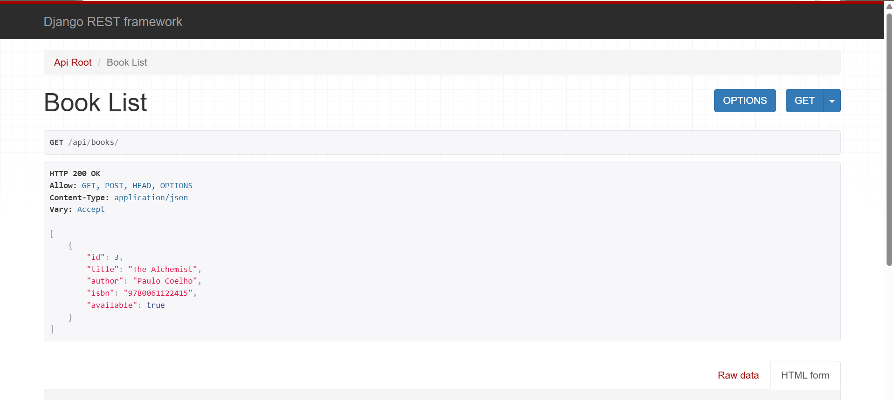

9. User Interface and Screenshots
The application provides a simple and user-friendly interface.

Main Page
The main page displays the Library Management System title, book entry form, search option, and book table.
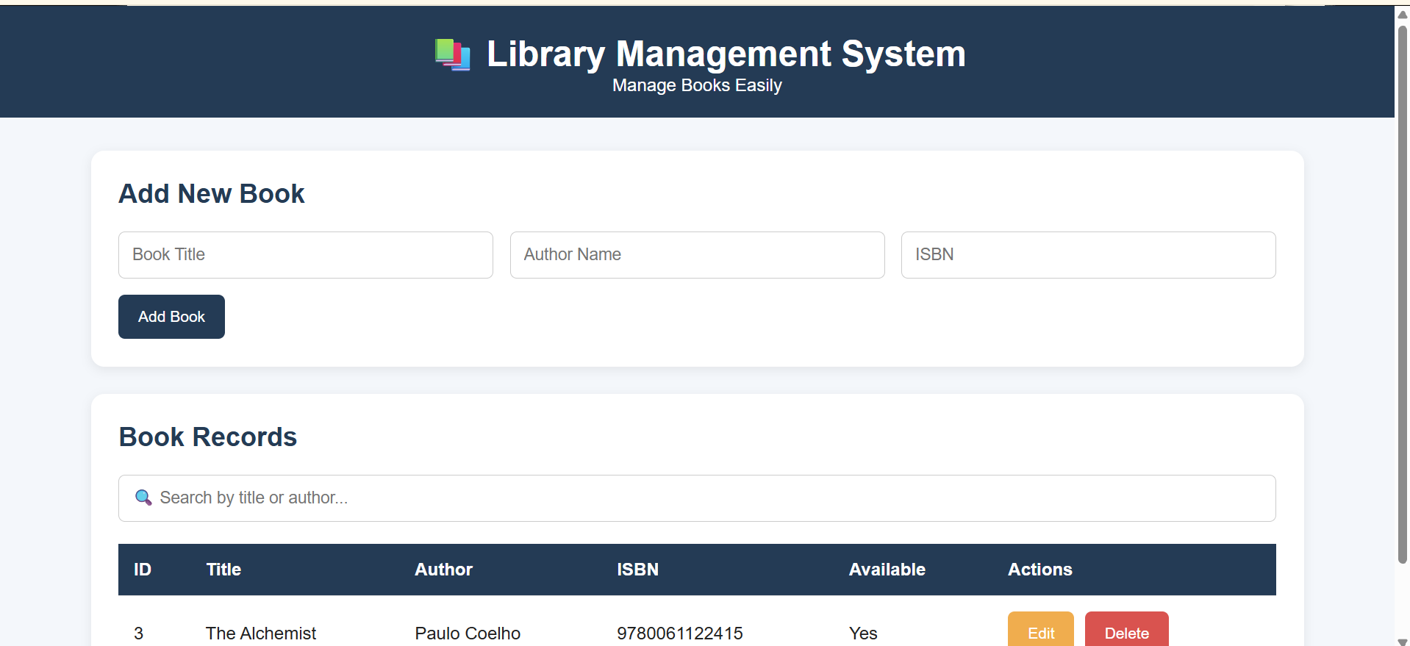

Adding a Book
Users can enter the title, author, and ISBN to add a new book.
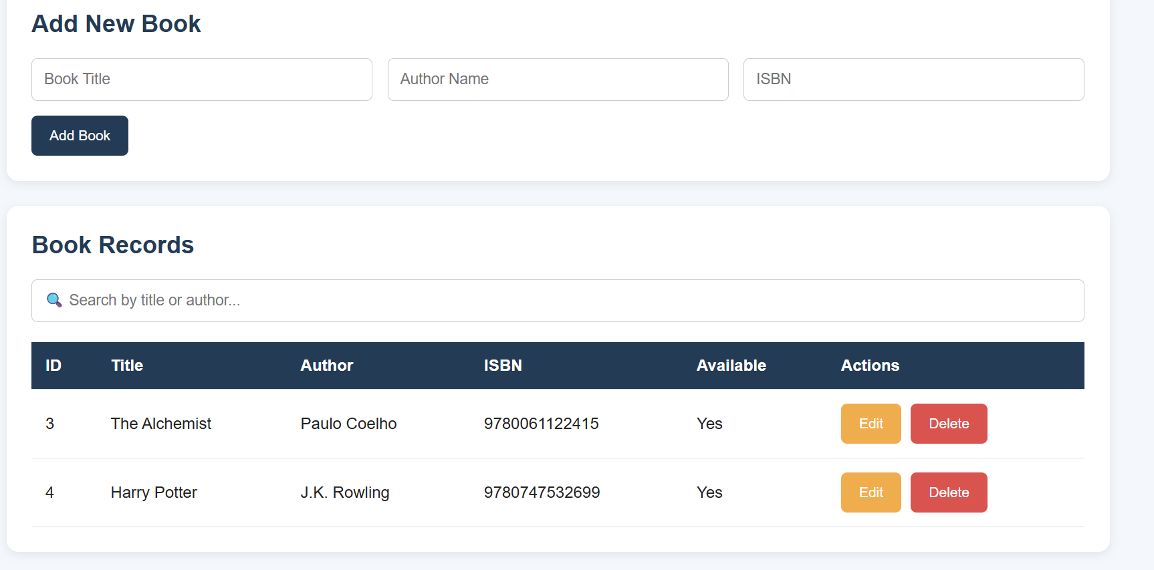

Updating a Book
Users can edit an existing book record and update its details.
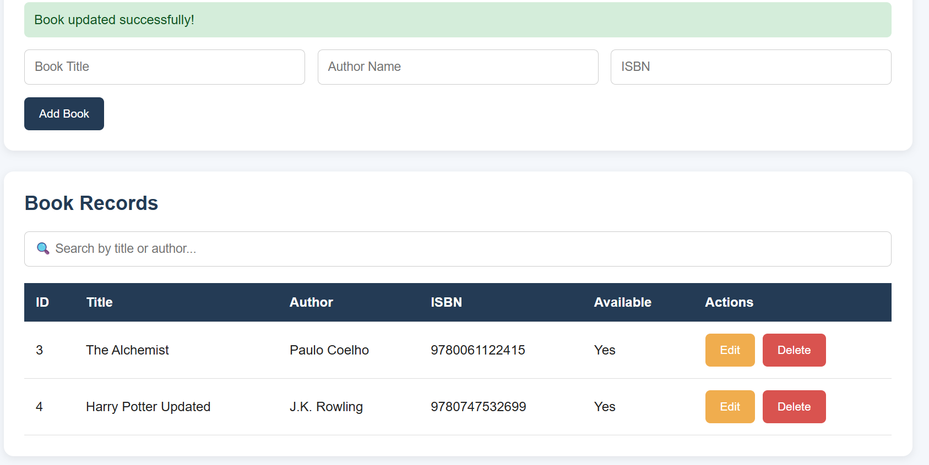

Deleting a Book
Users can delete an existing book record from the system.
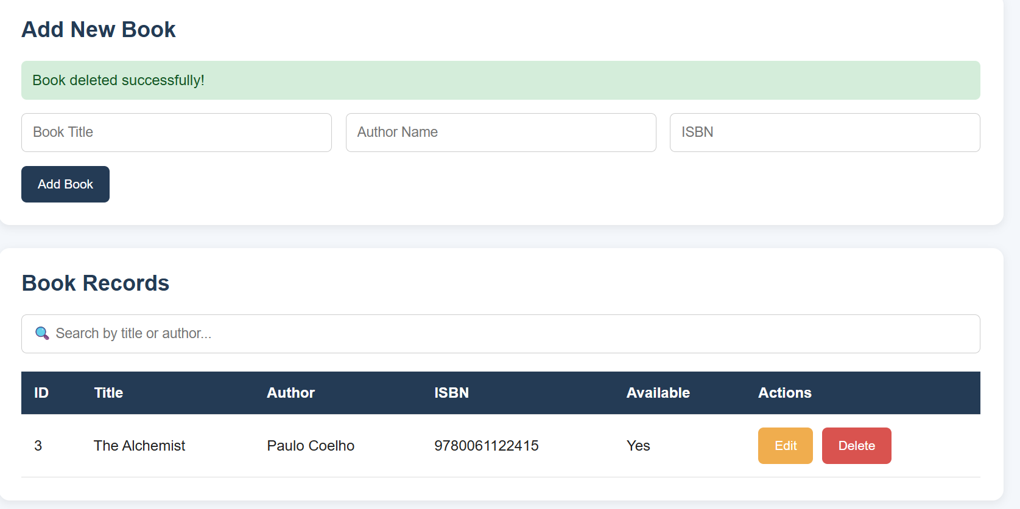

Book List
The system displays the available book records in a table.

10. Testing
Testing was performed to verify that the major functions of the application work correctly.
Test Case | Expected Result | Status
Open application | Home page should load | Passed
Add book | New book should appear | Passed
View books | Book records should be displayed | Passed
Update book | Book details should be modified | Passed
Delete book | Book should be removed | Passed
REST API | API should return book data | Passed
Duplicate ISBN | Duplicate ISBN should be prevented | Implemented
Empty input | Required fields should be checked | Implemented
The CRUD operations were successfully tested through the web interface and REST API.

11. Challenges and Solutions

Challenge 1: Connecting Frontend with Backend
The frontend needed to communicate with the Django backend.
Solution:
JavaScript fetch() was used to send HTTP requests to the REST API.

Challenge 2: Database Management
Book records needed to be stored permanently.
Solution:
Django models and SQLite database were used to store the book information.

Challenge 3: CRUD Implementation
The application needed Create, Read, Update, and Delete functionality.
Solution:
Django REST Framework ModelViewSet was used to implement the CRUD API operations.

Challenge 4: Duplicate Book Records
Duplicate ISBN numbers should not be allowed.
Solution:
The ISBN field was configured as unique in the Django model and validation was added to the frontend.

12. Future Enhancements
The following features can be added in future versions:
- User login and authentication.
- Student/member management.
- Book issue and return functionality.
- Due date and fine calculation.
- Admin dashboard.
- Book categories and genres.
- Advanced search and filtering.
- Book availability tracking.
- PostgreSQL or MySQL database support.
- Deployment of the application online.

13. Conclusion
The Library Management System successfully demonstrates the development of a CRUD-based web application.
The project combines HTML, CSS, JavaScript, Python, Django, Django REST Framework, and SQLite to provide a functional system for managing book records.
The application supports adding, viewing, updating, deleting, and searching books. REST APIs are used for communication between the frontend and backend.
This project also provides practical experience in database management, API development, frontend-backend integration, testing, Git, and GitHub.

14. GitHub Repository
The complete source code of the project is maintained in a GitHub repository.
Repository Name: Library-Management-System
https://github.com/logadharshini848/Library_Management_System/tree/main
The repository contains the Django project, books application, database, requirements file, and project documentation.

